SIMATS ENGINEERING

ASSESSMENT TOOL 2

COURSE NAME: Ethical Hacking COURSE CODE: ITA14

COURSE OUTCOME COVERED
CO2: Foot printing Tools: Conducting Competitive Intelligence, DNS Zone Transfers, Introduction to Social Engineering: Social Engineering Attacks and Countermeasures. (BT4)

Assessment Tool Weightage: 30%

Duration: 90 min Total Marks: 50

Social Engineering Simulation

Questions

- As a Security Analyst, perform an OSINT-based email enumeration assessment on the target domain tesla.com using theHarvester in Kali Linux. Collect publicly available email addresses, subdomains, hosts, and IP addresses associated with the organization. Categorize the discovered email addresses into likely roles such as Support, Sales, Human Resources, Administration, and Technical Teams. Analyze how the gathered information could assist an attacker during the reconnaissance phase and explain how it could be used for spear-phishing, credential harvesting, and impersonation attacks. Finally, recommend at least five countermeasures to reduce information leakage and social engineering risks, and submit a report with screenshots, commands executed, findings, risk analysis, and recommendations. (20 Marks)

- As a cybersecurity awareness consultant, you are required to conduct a phishing awareness simulation using GoPhish and dummy employee accounts provided in the lab. Create an email template, launch a campaign, monitor user interactions, and generate a report showing delivery rate, email open rate, and click rate. Based on the results, provide recommendations to improve user awareness against phishing attacks.(20 Mark).

- Using Nmap Aggressive Scan (-A) on scanme.nmap.org, gather detailed information about the target including operating system details, open ports, and service versions. Assume you are an attacker and describe how the collected information could be leveraged to conduct a social engineering attack against the IT support team. Prepare a report explaining the attack methodology and defensive recommendations.(10 Marks)

Code of Conduct:

I B.MALLIKA(192324234) (Name / Reg No) certify that this submission is my original work and that I have adhered to the guidelines specified for this assessment.
I understand that any violation of academic integrity rules will result in disciplinary action.

Signature of the student:
B.MALLIKA

RUBRICS FOR CALCULATION

Social Engineering Simulation

Criteria | Weightage (%) | Level 4 (Exemplary) | Level 3 (Proficient) | Level 2 (Developing) | Level 1 (Beginning)
Understanding of Social Engineering Scenario | 20% | Demonstrates a comprehensive understanding of the social engineering scenario, attack techniques, and  security context | Demonstrates good understanding with minor omissions. | Shows partial understanding but misses important aspects of the scenario. | Fails to understand or incorrectly interprets the social engineering scenario.
Identification of Attack and Vulnerabilities | 20% | Correctly identifies the attack type, exploited vulnerabilities, and  affected assets with complete accuracy | Correctly identifies most attack techniques with minor errors. | Identifies only some attack methods and vulnerabilities. | Unable to identify the attack type or associated vulnerabilities.
Application of Security Concepts and Countermeasu res | 25% | Effectively applies cybersecurity concepts and recommends appropriate preventive, detective, and  corrective countermeasures. | Applies relevant concepts with minor errors and recommends suitable countermeasures  . | Applies concepts partially with limited recommendation s. | Unable to apply relevant cybersecurity concepts or recommend suitable countermeasures  .
Risk Analysis and Decision Making | 20% | Performs logical risk analysis, evaluates business impact, and provides well-  justified security decisions. | Provides reasonable analysis with adequate justification. | Performs limited analysis with weak justification. | Provides no meaningful analysis or justification.
Clarity, Documentatio n and Technical Presentation | 15% | Response is well-organized, technically accurate, professionally  documented, and logically presented. | Response is clear with minor documentation or presentation issues. | Response lacks organization and contains technical inaccuracies. | Response is poorly organized, incomplete, and difficult to understand.

ANSWERS:

OSINT Email Enumeration Assessment using theHarvester
Aim
To perform an Open Source Intelligence (OSINT) assessment on the target domain tesla.com using theHarvester and identify publicly available email addresses, subdomains, hosts, and IP addresses.

Theory
theHarvester is an OSINT tool used to gather publicly available information about a target organization from search engines, certificate transparency logs, and other public sources. It helps security professionals understand what information about an organization is exposed online.

Commands
Update package list: sudo apt update
Explanation:
Updates the local package database before installing software.

Install theHarvester: sudo apt install theharvester
Explanation:
Installs theHarvester on Kali Linux if it is not already installed.

Verify installation: theHarvester --version
Explanation:
Displays the installed version of theHarvester.

Enumerate public information: theHarvester -d tesla.com -b all
Explanation:
- -d tesla.com specifies the target domain.
- -b all queries all supported public data sources.

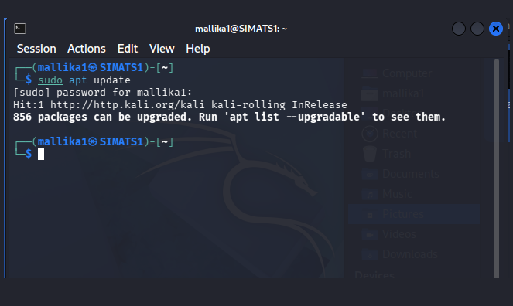
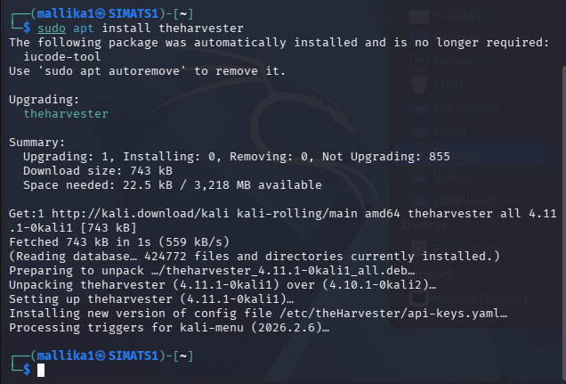
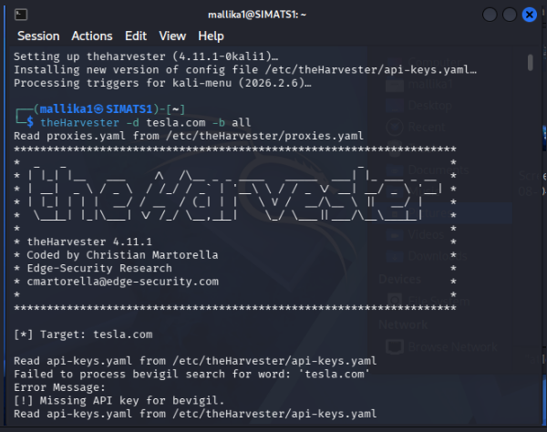

Findings
- Record the information actually returned by your scan.
- Email Addresses
- List the public email addresses found.
- Subdomains
- List the discovered subdomains.
- Hosts
- List the discovered hosts.
- IP Addresses
- List the IP addresses associated with the organization.

Risk Analysis
- Spear-Phishing
- An attacker can create personalized emails that appear to come from trusted internal departments, making employees more likely to interact with malicious links or attachments.
- Credential Harvesting
- Attackers may imitate corporate login pages and send convincing emails to collect usernames and passwords.
- Impersonation
- Attackers can impersonate IT support, HR, or administrators using publicly known names, email formats, or department information to request sensitive information.

Countermeasures
- Minimize publicly exposed email addresses.
- Implement SPF, DKIM, and DMARC.
- Use Multi-Factor Authentication (MFA).
- Conduct regular phishing awareness training.
- Monitor publicly available information using OSINT tools.
- Use generic contact addresses where appropriate instead of publishing individual employee emails.

Phishing Awareness Simulation using GoPhish
Aim
To conduct a phishing awareness simulation using GoPhish with dummy employee accounts and analyze user interactions.

Theory
GoPhish is an open-source phishing simulation platform used for employee awareness training. It allows organizations to safely test how users respond to phishing emails and identify areas for improvement.

Commands
Make the GoPhish binary executable
chmod +x gophish
Explanation:
Grants execute permission to the GoPhish application.

Start GoPhish
sudo ./gophish
Explanation:
Starts the GoPhish admin interface and phishing server.

Access the Dashboard
Open:
https://127.0.0.1:3333
Log in using the credentials displayed in the terminal.

Steps Performed
- Launch GoPhish.
- Create a sending profile.
- Create an email template.
- Create a landing page.
- Import dummy employee accounts.
- Launch the phishing campaign.
- Monitor the campaign dashboard.

Sample Email Template
Subject: Password Verification Required
Body:
Dear Employee,

The IT department has initiated a mandatory password verification process.

Please verify your account using the secure company portal.

Thank you,
IT Support
Use only dummy accounts in your lab.

Screenshot
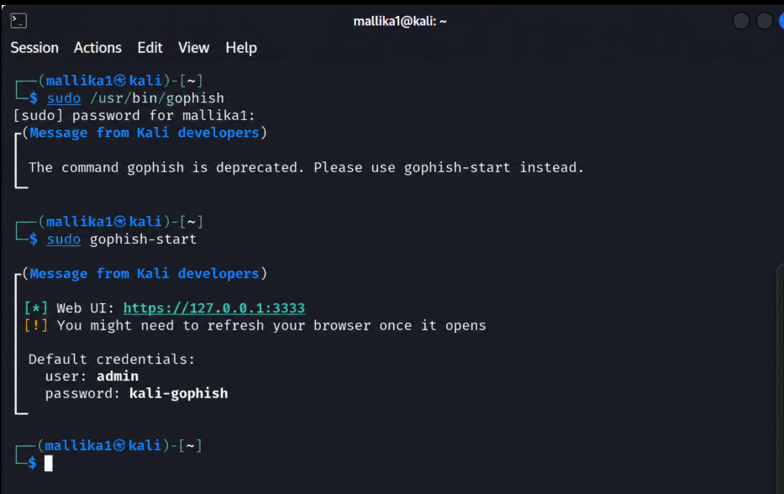

Recommendations
- Conduct phishing awareness training regularly.
- Encourage users to verify email senders before responding.
- Report suspicious emails promptly.
- Enable MFA.
- Deploy advanced email filtering.
- Verify urgent requests through a second communication channel.

3.Nmap Aggressive Scan on scanme.nmap.org
Aim
To perform an aggressive Nmap scan on scanme.nmap.org and identify open ports, services, versions, and operating system details.

Theory
Nmap is a network scanning tool used to discover hosts, identify open ports, detect running services, estimate the operating system, and gather version information.

Commands
Verify installation
Bash
nmap --version
Explanation:
Displays the installed Nmap version.

Perform Aggressive Scan
Bash
nmap -A scanme.nmap.org
Explanation:
- -A enables OS detection, version detection, script scanning, and traceroute.

Screenshot
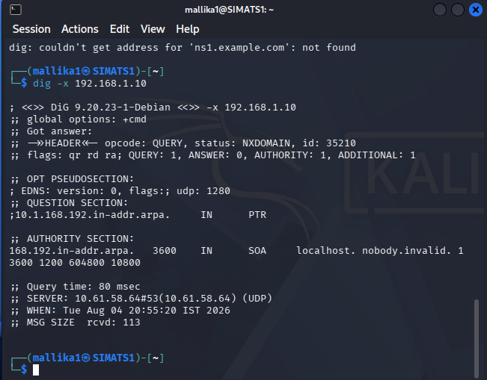
Findings
Record the actual results from your scan.
Open Ports
Port | Service | Version
(Actual results)
Operating System
Record the OS information reported by Nmap.
Service Versions
Record the versions reported by Nmap.

Social Engineering Attack Methodology (Hypothetical)
If an attacker learns what services and software versions are in use, they may:
- Craft convincing emails that reference the organization's actual technology.
- Impersonate IT support requesting a software update.
- Send fake security notices related to identified services.
- Increase the credibility of phishing emails by mentioning real infrastructure.
This describes a hypothetical attack path for awareness and defense planning.

Defensive Recommendations
- Keep systems updated and patched.
- Disable unnecessary services.
- Limit information exposed in service banners.
- Use network segmentation.
- Deploy intrusion detection and monitoring.
- Train employees to verify requests from IT support.
- Enable MFA for administrative accounts.

Conclusion
These experiments demonstrate how publicly available information, phishing simulations, and network reconnaissance can help organizations identify security risks and strengthen their defenses. By reducing information exposure, improving employee awareness, and maintaining secure configurations, organizations can significantly lower the risk of phishing and social engineering attacks.

